Personal effectiveness

**Contents**

**Your personal brand** 4

**EQ Self - Assessment Questionnaire** 7

**Activity – where are you?**

**Rate yourself in each of the characteristics of a high performer with 1 being ‘I don’t do this at all’ and 10 being ‘This is something that I always do’**

|  |  |  |
| --- | --- | --- |
| Characteristic | Where are you now? | Where you’d want to be at end of Novus |
| Good internal compass |  |  |
| Goes the extra mile |  |  |
| Team player |  |  |
| Positive mindset |  |  |
| Seeks growth opportunities |  |  |
| Networking |  |  |
| Understands the end goal |  |  |
| Self-aware |  |  |

**What do you need to:**

**Start doing?**

**Stop doing?**

**Continue to do?**

# **Your personal brand**

[Everything you do either strengthens or dilutes the personal brand you’re trying to create.](https://twitter.com/intent/tweet?url=http%3A%2F%2Fwww.forbes.com%2Fsites%2Fjosephliu%2F2018%2F04%2F30%2Fpersonal-brand-work%2F&text=Everything%20you%20do%20either%20strengthens%20or%20dilutes%20the%20personal%20brand%20you%E2%80%99re%20trying%20to%20create.%20-%40JosephPliu%20%40Forbes) Building a strong personal brand is a choice. Personal branding takes time, effort, and energy. However, investing your energy to selectively engage with specific projects, conferences, meetings, relationships, and influencers can help you build a focused reputation. If you don’t, you may be leaving yourself open to being labelled in ways that don’t align with the type of professional you want to be. [Personal branding is a way of establishing and consistently reinforcing who you are and what you stand for in your career and life.](https://twitter.com/intent/tweet?url=http%3A%2F%2Fwww.forbes.com%2Fsites%2Fjosephliu%2F2018%2F04%2F30%2Fpersonal-brand-work%2F&text=Personal%20branding%20is%20a%20way%20of%20reinforcing%20who%20you%20are%20and%20what%20you%20stand%20for%20in%20your%20career%20and%20life%20-%40JosephPLiu)

**Assess yourself against the following behaviours.**

|  |  |  |
| --- | --- | --- |
| **Negative brand behaviours** | | **Rating** |
| Gossip | Never | Sometimes | Mostly | Always | |
| Judge others | Never | Sometimes | Mostly | Always | |
| Be negative | Never | Sometimes | Mostly | Always | |
| Fish for compliments | Never | Sometimes | Mostly | Always | |
| Make excuses | Never | Sometimes | Mostly | Always | |
| Lie | Never | Sometimes | Mostly | Always | |
| Blame others | Never | Sometimes | Mostly | Always | |
| Be very pushy with your opinions | Never | Sometimes | Mostly | Always | |
| Be sarcastic | Never | Sometimes | Mostly | Always | |
| Be an energy DRAIN | Never | Sometimes | Mostly | Always | |
| Moan/complain | Never | Sometimes | Mostly | Always | |
| Boast | Never | Sometimes | Mostly | Always | |
| Don’t listen to others | Never | Sometimes | Mostly | Always | |
| Don’t show your vulnerability | Never | Sometimes | Mostly | Always | |
| Be untrusting | Never | Sometimes | Mostly | Always | |
| Have closed or aggressive body language | Never | Sometimes | Mostly | Always | |
| Look at your phone when others are talking | Never | Sometimes | Mostly | Always | |
| Be unreliable/not follow through on commitments | Never | Sometimes | Mostly | Always | |

|  |  |
| --- | --- |
| **Positive brand behaviours** | **Rating** |
| Want good for others | Never | Sometimes | Mostly | Always |
| Respect others | Never | Sometimes | Mostly | Always |
| Be positive | Never | Sometimes | Mostly | Always |
| Complement others | Never | Sometimes | Mostly | Always |
| Be accountable | Never | Sometimes | Mostly | Always |
| Tell the truth | Never | Sometimes | Mostly | Always |
| Say sorry [when appropriate] | Never | Sometimes | Mostly | Always |
| Be interested in others | Never | Sometimes | Mostly | Always |
| Show compassion | Never | Sometimes | Mostly | Always |
| Smile/Laugh [kindly] | Never | Sometimes | Mostly | Always |
| Be a RADIATOR | Never | Sometimes | Mostly | Always |
| Be optimistic | Never | Sometimes | Mostly | Always |
| Show humility | Never | Sometimes | Mostly | Always |
| Focus on others and notice what they need or want to talk about | Never | Sometimes | Mostly | Always |
| Listen deeply to others | Never | Sometimes | Mostly | Always |
| Be authentic | Never | Sometimes | Mostly | Always |
| Be open - share thoughts and feelings | Never | Sometimes | Mostly | Always |
| Have open body language | Never | Sometimes | Mostly | Always |

**Review your answers, based one what you notice answer the questions on the following page.**

**What would people (colleagues, your manager, other stakeholders) say about you and your brand (if they had taken a truth pill and you weren’t in the room)?**

**What would they say about your trustworthiness?**

**What would people say about the level of accountability you take?**

**Would others describe you as curious?**

**What would people say about your impact e.g. to the team, project, customers, wider business?**

# **EQ Self - Assessment Questionnaire**

**There are no right or wrong answers. Please read each statement and decide how strongly the statement applies to you.** Rate yourself from 0 to 5 based on the following guide: 0 = Never applies 3 = Applies half the time 5 = Always applies. You may use numbers 1,2 and 4 also.

|  |  |  |
| --- | --- | --- |
| 1 | I realise when I am about to lose my temper | 4 |
| 2 | I know when I am happy and content | 5 |
| 3 | I quickly recognise when I am becoming anxious or stressed | 4 |
| 4 | When I am being ‘emotional’ I am aware of this | 2 |
| 5 | When I feel anxious I can usually account for the reason(s) | 4 |
| 6 | I always know when I am being unreasonable | 3 |
| 7 | Being aware of my own emotions is very important to me | 2 |
| 8 | I am aware of the inner- dialogue (self-talk) that I have with myself | 4 |
| 9 | I regularly reflect on how I am feeling and why I feel that way | 2 |
| 10 | I know what makes me happy | 4 |
|  | **Total** | 34 |

|  |  |  |  |  |
| --- | --- | --- | --- | --- |
| 11 | I can ‘reframe’ bad situations quickly | | 3 | |
| 12 | I do not wear my ‘heart on my sleeve’ | | 5 | |
| 13 | I do not allow my moods to control me or impact on other people | | 4 | |
| 14 | I rarely ‘fly off the handle’ at other people | | 4 | |
| 15 | Difficult people do not annoy or agitate me | | 3 | |
| 16 | I can consciously alter my frame of mind or mood | | 2 | |
| 17 | I do not let stressful situations or people affect me once I have left work | | 3 | |
| 18 | I rarely worry about work or life in general | | 3 | |
| 19 | I can suppress my emotions when I need to | | 4 | |
| 20 | I am good at delaying emotional gratification (being patient, biting my tongue) | | 3 | |
|  | **Total** | | 34 | |
| 21 | I am always able to motivate myself to do difficult or mundane tasks | 4 | |
| 22 | I am usually able to prioritise important activities at work & get on with them | 3 | |
| 23 | I always meet deadlines | 3 | |
| 24 | I never waste time (procrastinate, dither) | 2 | |
| 25 | I do not prevaricate (deceive by speaking or acting in an evasive way) | 3 | |
| 26 | I believe you should usually do the difficult or unpleasant things first | 3 | |
| 27 | I can always motivate myself even when I feel low | 4 | |
| 28 | I believe in ‘action this day’ and making things happen | 3 | |
| 29 | I am responsible for my own happiness, successes and perceived failures | 4 | |
| 30 | Self-Motivation has been one of the great keys to my success | 3 | |
|  | **Total** | 32 | |
|  |  |  | |
| 31 | I am always able to see things from other people’s point of view | 3 | |
| 32 | I am good at empathising with other people’s problems or successes | 2 | |
| 33 | I can tell if someone is not happy with me | 2 | |
| 34 | I am good at adapting and mixing with a variety of people | 2 | |
| 35 | I can usually understand why people are being difficult towards me | 2 | |
| 36 | Other individuals are not ‘difficult’ just ‘different’ | 4 | |
| 37 | I can see from people’s expressions and eyes how they are feeling | 1 | |
| 38 | I can understand why my actions sometime offend others | 3 | |
| 39 | I can sense and articulate how other people are feeling | 2 | |
| 40 | The underlying causes of disagreements are always clear to me | 3 | |
|  | **Total** | 24 | |
|  |  |  | |
|  |  |  | |
|  |  |  | |

|  |  |  |
| --- | --- | --- |
| 41 | I am an excellent listener | 4 |
| 42 | I am good at adapting and mixing with a wide range of people | 3 |
| 43 | I like to ask questions to find out what is important to people | 3 |
| 44 | Relationships are the most interesting thing in life for me | 1 |
| 45 | I enjoy meeting new people and getting to know what makes them ‘tick’ | 1 |
| 46 | I am good at reconciling disagreements with other people | 2 |
| 47 | Having a wide variety of work colleagues makes my job more interesting | 4 |
| 48 | I am good at disagreeing without being disagreeable | 3 |
| 49 | I am quick to understand why some people think and act differently to me | 3 |
| 50 | I generally build strong, stable & lasting relationships with those I work with | 3 |
|  | **Total** | 27 |

**Activity - reflection**

**Total up your scores from your self-assessment and complete the radar chart below.**

Q1-10 = Your self-awareness score

Q11-20 = Your Self-regulation score

Q21-30 = Your Motivation score

Q31-40 = Your Empathy score

Q41-50 = Your Interpersonal skills score

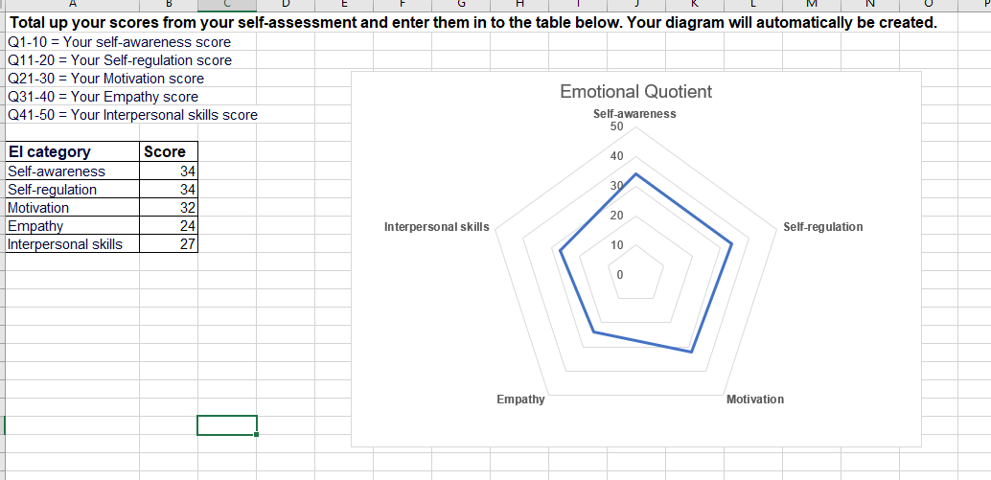

**What do your scores mean for you?**

**What examples can you identify where you have been emotionally intelligent?**

**What examples can you think of where you reacted in a way that wasn’t emotionally intelligent?**

**What could you do in your work life to be more emotionally intelligent?**